# MY PROTOCOL for GitHub

1. To set your global username/email configuration:

Open the command line.

Set your username:

git config --global user.name "FIRST_NAME LAST_NAME"

Set your email address:

git config --global user.email "MY_NAME@example.com"

1. git init in your local folder
2. .git remote add origin "GitHub repo URL"
3. keep doing git status (Add Commit Push)
4. git pull origin master --allow-unrelated-histories
5. git push origin master
6. (if files are HUGE) git config --global http.postBuffer 157286400

Or use GIT LFS

MORE NOTES  
Referred Videos

<https://www.youtube.com/watch?v=Fk12ELJ9Bww&t=24s>

Referred Playlist

<https://www.youtube.com/watch?v=xKVlZ3wFVKA&list=PL5-da3qGB5IBLMp7LtN8Nc3Efd4hJq0kD>

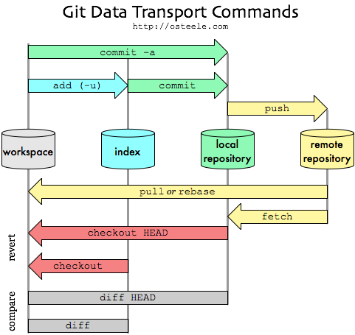

# MORE QUERIES

**The “fatal: refusing to merge unrelated histories” Git error**

<https://www.educative.io/edpresso/the-fatal-refusing-to-merge-unrelated-histories-git-error>

# [Troubleshooting misplaced .git directory (nothing to commit)](https://stackoverflow.com/questions/22067873/troubleshooting-misplaced-git-directory-nothing-to-commit)

# <https://stackoverflow.com/questions/22067873/troubleshooting-misplaced-git-directory-nothing-to-commit>

# Configure your DVCS username for commits

<https://confluence.atlassian.com/bitbucket/configure-your-dvcs-username-for-commits-950301867.html>

# [Cannot edit in read-only editor VS Code](https://stackoverflow.com/questions/54856374/cannot-edit-in-read-only-editor-vs-code)

<https://stackoverflow.com/questions/54856374/cannot-edit-in-read-only-editor-vs-code/56463139>

# [git error: failed to push some refs to](https://stackoverflow.com/questions/24114676/git-error-failed-to-push-some-refs-to)(kinda merge conflict)

<https://stackoverflow.com/questions/24114676/git-error-failed-to-push-some-refs-to>

# [LF will be replaced by CRLF in git - What is that and is it important? [duplicate]](https://stackoverflow.com/questions/5834014/lf-will-be-replaced-by-crlf-in-git-what-is-that-and-is-it-important)

<https://stackoverflow.com/questions/5834014/lf-will-be-replaced-by-crlf-in-git-what-is-that-and-is-it-important>

# Git Push Fails - fatal: The remote end hung up unexpectedly

<https://confluence.atlassian.com/stashkb/git-push-fails-fatal-the-remote-end-hung-up-unexpectedly-282988530.html>